WALLACE FIELDS JUNIOR SCHOOL
READING AT HOME
Once children have learnt to decode words, they then need to develop comprehension skills to help them to understand a variety of different texts. When you are reading with your child you can help them to improve their understanding by discussing what they have read.

Ask them questions about the text, their ideas about what could happen next or whether they are enjoying the book. Encourage them to tell you what stories and information they know. Discuss their opinions about how things might be different in stories or in the world.
Let them see you, and join you in, reading; TV, magazines, letters, instructions, charts, signs … and remember your child will like to hear you read to them as much as they like reading to you!
Here is a selection of questions that can be used. Children need to answer a number of different types of questions – these can be simply questions where they recall the answer from the text or questions that require then to understand inferences, make deductions, evaluate and analyse.
By asking your child a variety of these questions, you will be helping them to progress with their reading and understanding. They will then also use these skills to progress with their writing.
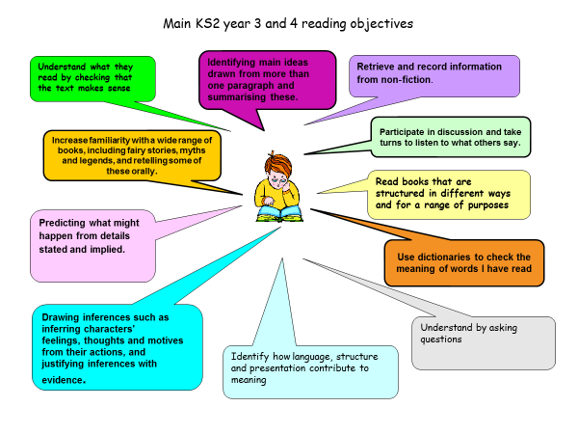

Literal questions for Fiction
Where does the story take place?
When did the story take place?
What did the character look like?
Where did the character live?
Who are the key characters in the book?
What happened in the story?
What kinds of people in the story?
Explain something that happened at a specific point in the story?

Inferred questions for Fiction
If you were going to interview this character/author, which questions would you ask?
Which is your favourite part? Why?
Who was the storyteller? How do you know?
Predict what you think is going to happen next. Why do you think this?
How is the main character feeling at the start/middle/end of the story? Why do they feel that way?

Fiction – Discuss language, structure and presentation
Were you surprised by the ending? Is it what you expected? Why/why not?
What is the main event of the story? Why do you think this?
How did you think it would end/should end?
Is so, describe it and say why you think they did this?
Has the author put certain words in bold or italic? Why have they done this?
Why did the author choose this title?
Do you want to read the rest of the text? How does the writer encourage you to read the rest of the text?
Can you find some examples of effective description? What makes them effective?
Which part of the story best describes
the setting?
Can you find examples of powerful adjectives? What do they tell you about a character or setting?
Find an example of a word you don’t know the meaning of. Use a dictionary to find out what it means.

Discussing texts
What is the text about? What is the title of the text?
Who is the author of the text?
What kind of things would you expect to see in this book?
Find something that interests you from the text.
Where would you look to find out what a technical word means?
What is on the cover of the book? What does this tell you about what might be inside?

Inferred questions for Non Fiction
Which parts of the book could help you find the information you need?
When would you use the contents page in the book?
When would you use the index page in the book?
What sort of person do you think would use this book?
When might someone use this book? Why?

Non Fiction - Discuss language, structure and presentation
Can you find an example of a page you think has an interesting layout? Why did you choose it?
Why have some of the words been written in italics?
What are the subheadings for?
Why have some of the words been written in bold?
What is the purpose of the pictures?
Find an example of a subject specific word (e.g. A book about the environment – ‘recyclable’)
Why do we need a glossary in a text?

